**N4DIG08 8ch Input Output module Manual**

**Features:**

1 Working voltage: DC 12V (6-24V)

2 Working current: 10-16MA

3 MODBUS RTU 03 06 16 command control mode

4 Three functional modes can be selected by jumpers: 8 channel input/8 channel output/4 input 4 output

5 Input mode: support 3.3V/5V TTL level input, there are two input modes: low level input (default) and high level input

6 Output mode: 5V TTL level, low level (default)/high level output

7 In MODBUS command mode, it can support up to 247 devices to be used in parallel

8 Input port status supports query (default) and automatic reporting

9 The default baud rate is 9600BPS, which can be configured to support 1200 2400 4800 19200 baud rate

10 Size: 44*31*15

11 Weight: 9 grams (no Pin), 10 grams (with Pin), 12.5 grams (with Terminals)

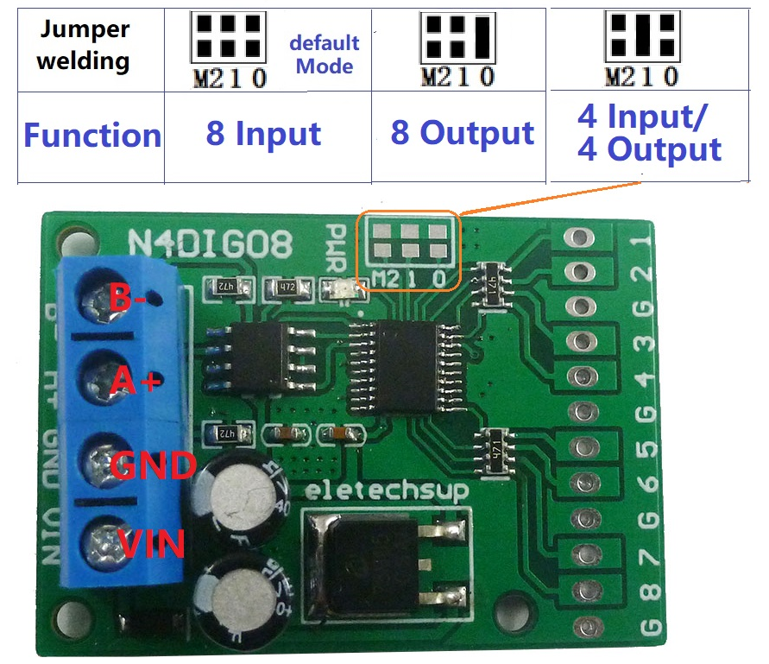

Choose different functions through jumpers on the board:

As 8-channel inputs Please refer to "N4DIG08 MODBUS RTU instruction (8-channel input)"

As 8-channel outputs Please refer to "N4DIG08 MODBUS RTU instruction (8-channel output)"

As 4 input 4output Please refer to "N4DIG08 MODBUS RTU instruction (4 Input 4 Output)"

As an 8-channel input wiring diagram:

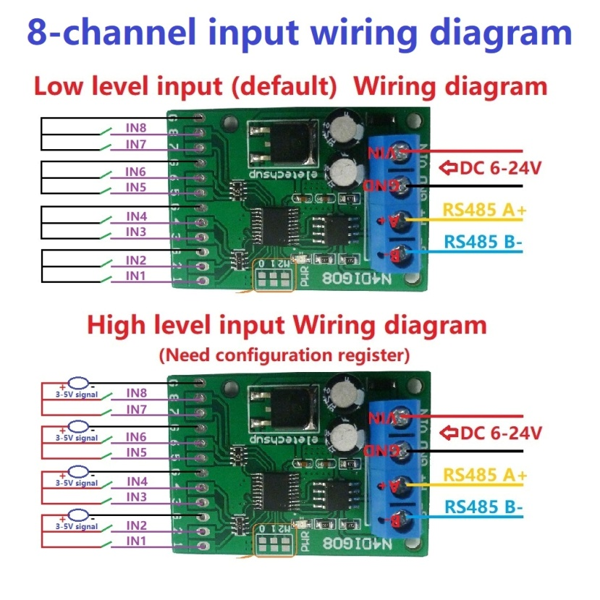

As an 8-channel output wiring diagram:

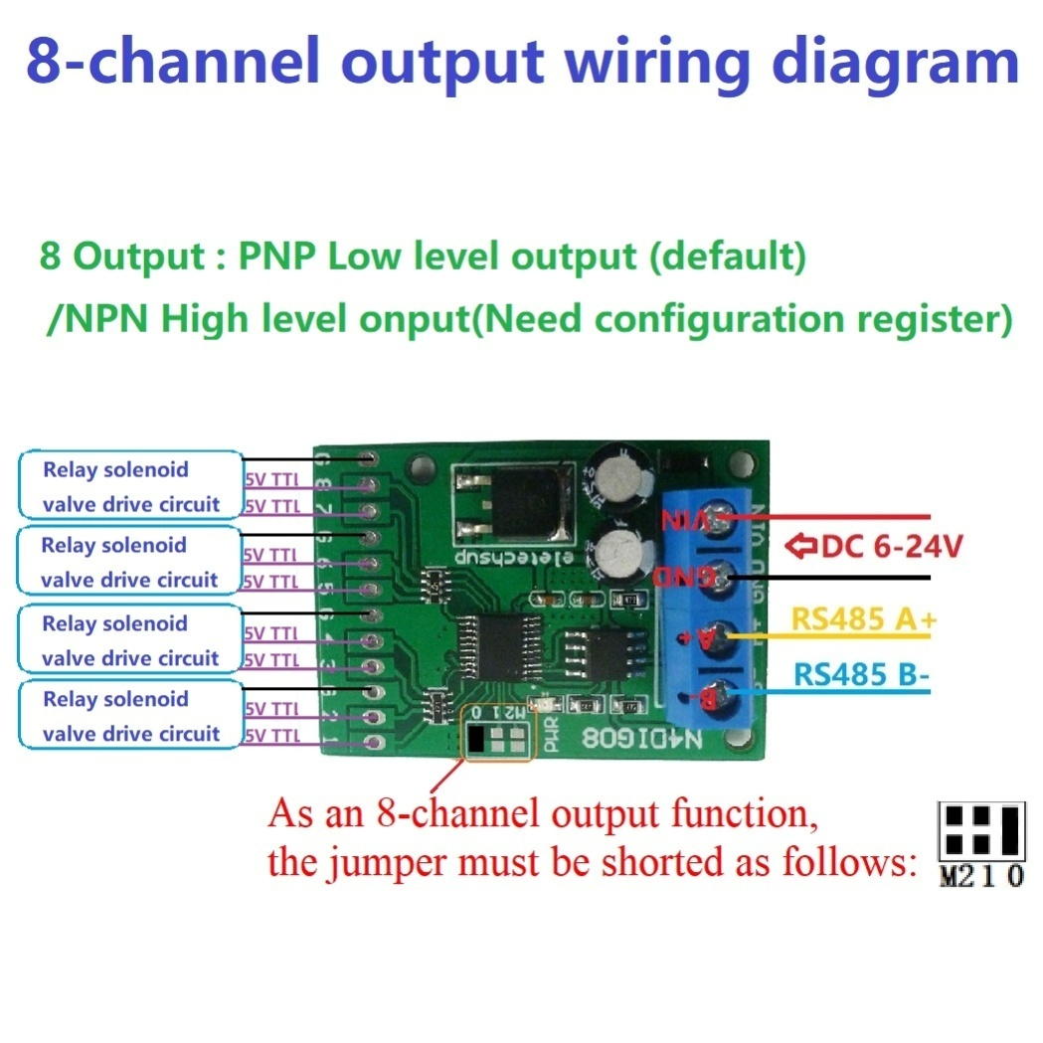

As a 4 input 4 output wiring diagram:

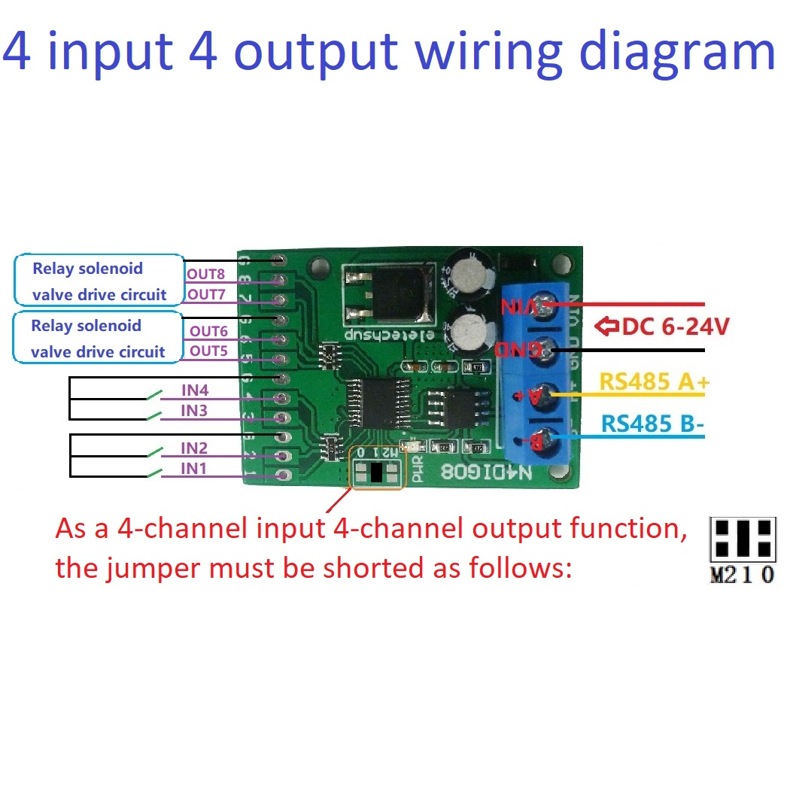

**RS485 Wiring diagram:**

